Using the Proofreading spreadsheet
The Proofreading spreadsheet can be used to check that your transcription matches what you intended to write.

Background definitions/explanations
Some basic concepts: Signwriting is based on the idea of receptive and expressive writing, and most people use expressive writing which is written from the writer’s perspective. Writer’s perspective and not signer perspective is chosen to provide consistent directions for signs made on the body or behind the body. The writer must imagine that he or she is behind the signer. An imaginary viewer is placed in front of the signer. The cardinal direction values are therefore writer-viewer, up-down, right-left. There are three planes of action and orientation – floor plane (writer-viewer, right-left), front wall plane (up-down, right-left) and the sidewall plane (writer-viewer, up-down).
One direction set that can be confusing is Viewer-Left (and Viewer-Right). This does NOT mean the viewer’s left but rather from the perspective of the writer, the area to the left of the imaginary viewer which includes the viewers right arm.
Digits on the hand are usually abbreviated as TIMRP (thumb index middle ring and pinky).

How to create a translation for a puddle

Download the proofreading spreadsheet from https://signtyp.uconn.edu/Transcriberinfo/transcriberinfoindex.html

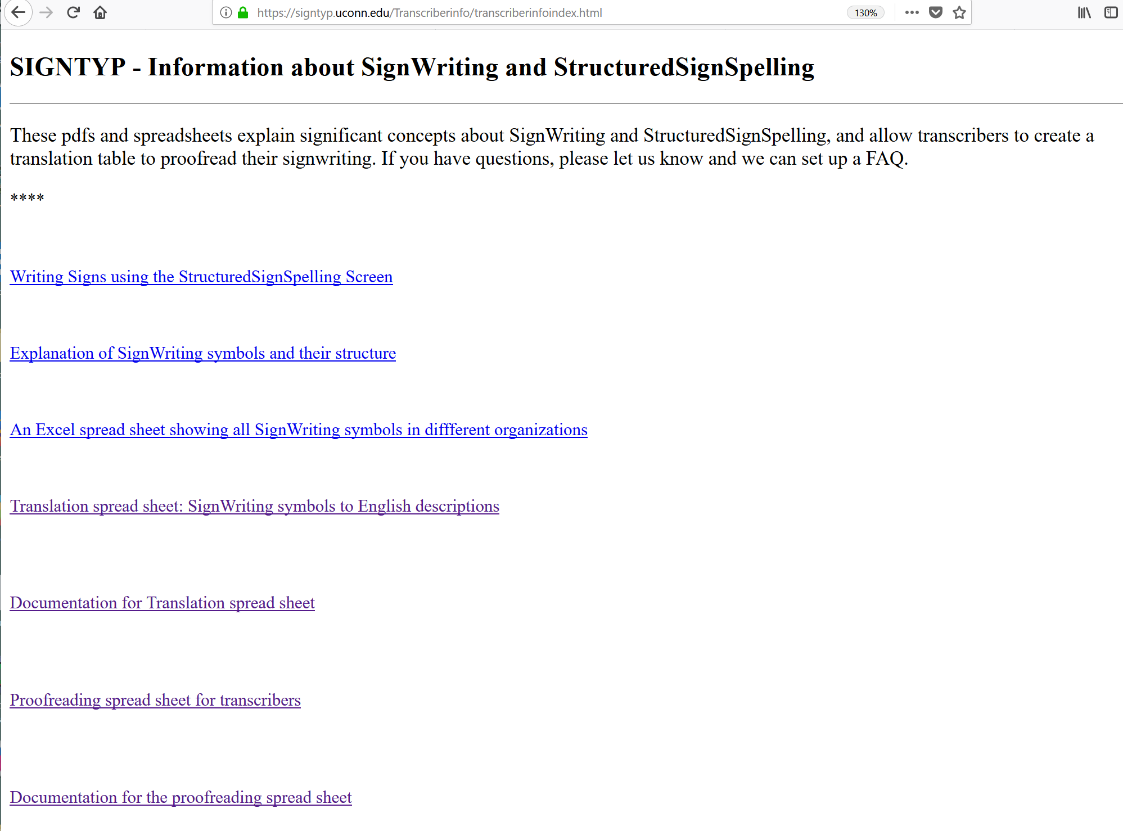

Click on Proofreading spreadsheet for transcribers. Open the spreadsheet. It will look like this:
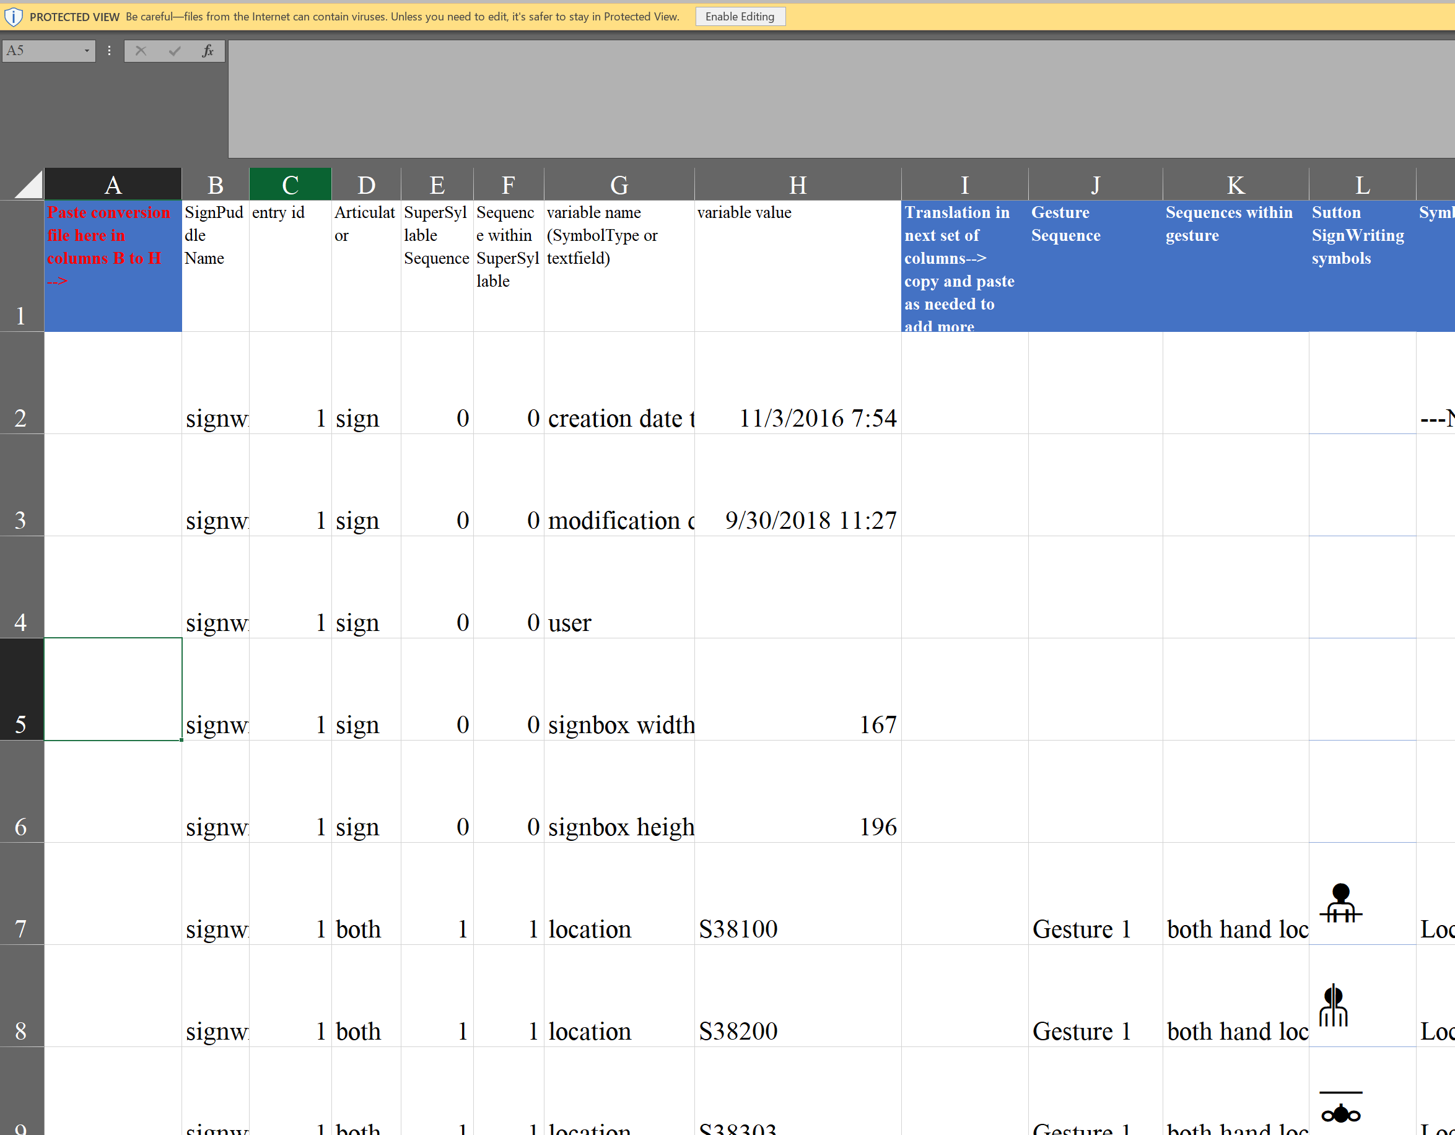

Now go to the puddle page and export the puddle you want to look at. I selected Portugal3. Click on Export, near the left bottom:

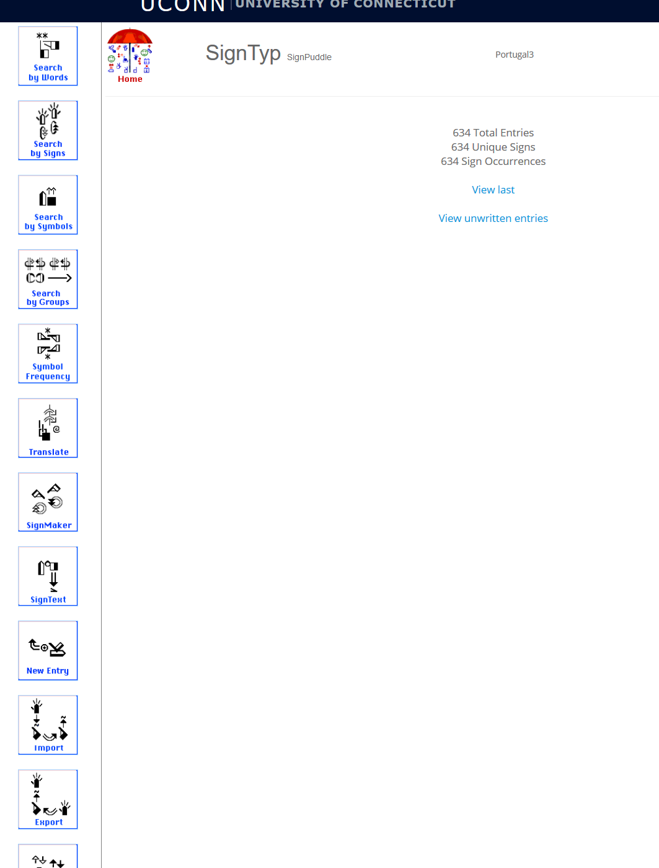
A new window opens. Click on SignTyp Conversion

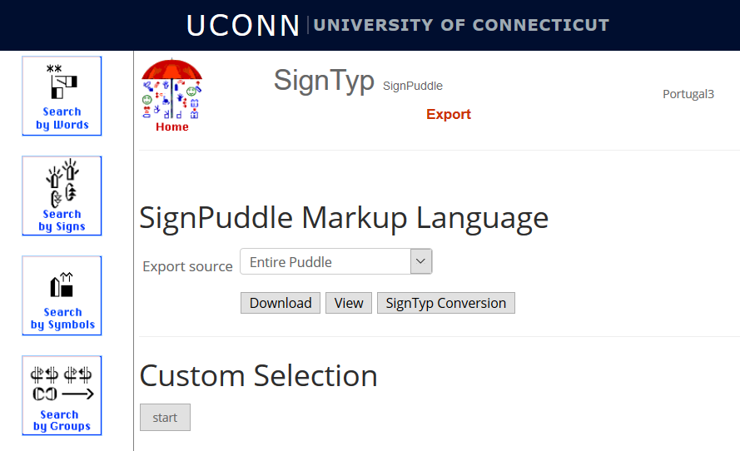
A new window opens:
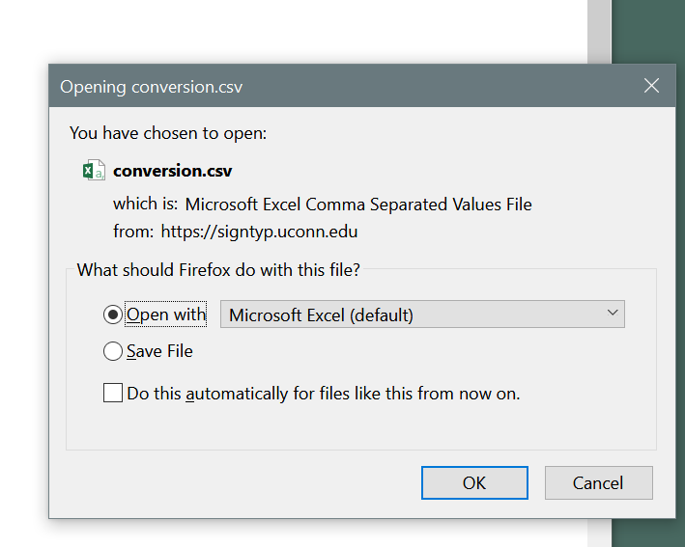
Click ok.
A second spreadsheet opens called conversion.csv. It will be similar to this:

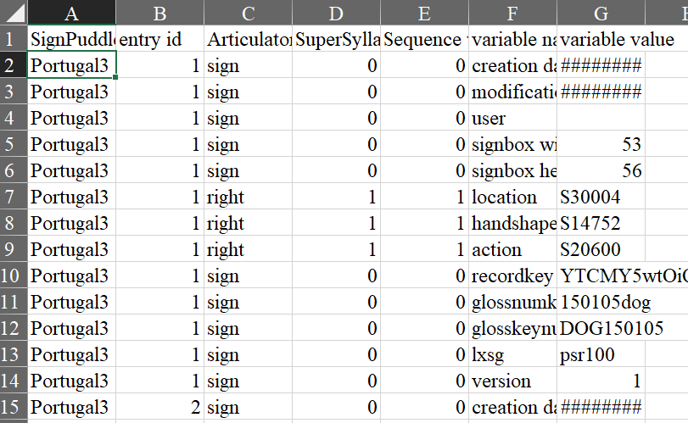

The number of columns will always be the same but the number of rows depends on the number of signs and symbols transcribed in the selected puddle.
Select the entire columns A-G (Shift-click), copy them (Ctrl-C) and then paste them into the translateforproofreading spreadsheet in columns B-H (click on column B, Ctrl-V).
If you want to proofread the entire file you will need to copy and paste the formulas in translation columns J to M into the rows you want translated. However, the first 70 or so rows are copied for you, so you can look at the first few signs without doing this.

How the translation works
In this example, the first sign is DOG. DOG has a flat unspread right hand with thumb tucked in. The hand is oriented so that the fingers point left, and the palm faces down. The hand strikes the chin two times. Do our symbol translations agree with this information?
There are 12 records or rows for this sign, which include information about the glosskey, the language, the sign version and other background or meta-information about the sign. The rows we are interested in are those that translate the SignWriting Symbols into text. In this example, this is rows 7 to 9. The columns of special interest are columns J to M:

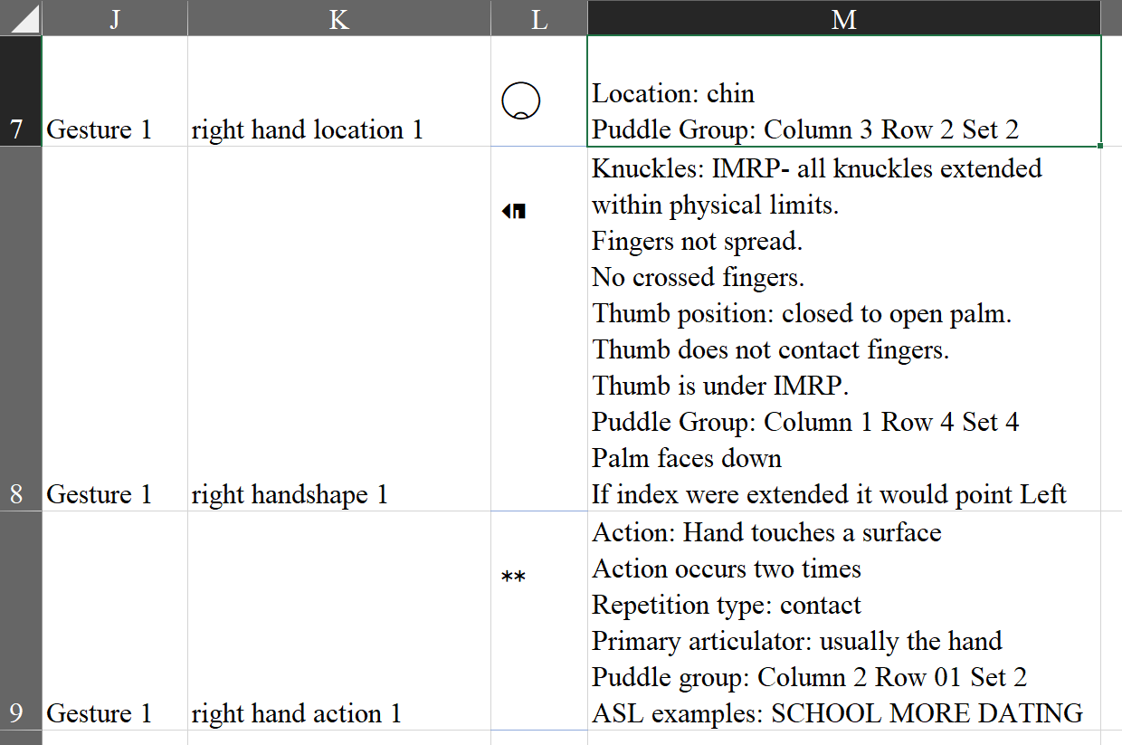

Column J tells us which gesture this symbol applies to. A sign may have one or more gestures – simple signs, like DOG, have one gesture, compound signs will have two or more gestures.
Column K tells us which hand is involved, whether it is a location, handshape or action, and the sequence if there are several occurrences of a parameter. In DOG, each parameter (location of right hand, right handshape, action of right hand) has only one occurrence.
Column L is a reminder of what the symbol looks like in the puddle. This column will display blanks if you don’t have the correct fonts installed. You can still use this spreadsheet, but it will be harder to understand. To see the signwriting symbols on the spreadsheet, install the Signwriting fonts on your computer, using this link:
https://slevinski.github.io/SuttonSignWriting/components/fonts.html
Column M is the most important column. It provides a translation of what the symbol means. It also tells you where the symbol is found in the SignPuddle SignMaker screen.
Compare the translation in column M with the simple description of DOG from above:

Gesture number | Parameter sequence | Computer generated symbol description (column M) | sign description in ordinary English
Gesture 1 | right hand location 1 | Location: chin  Puddle Group: Column 3 Row 2 Set 2 | strikes the chin two times.
Gesture 1 | right handshape 1 | Knuckles: IMRP- all knuckles extended within physical limits.  Fingers not spread.  No crossed fingers.  Thumb position: closed to open palm.  Thumb does not contact fingers.  Thumb is under IMRP.  Puddle Group: Column 1 Row 4 Set 4 | DOG has a flat unspread hand with thumb tucked in
 |  | Palm faces down  If index were extended it would point Left | The hand is oriented so that the palm faces down, and fingers point left.
Gesture 1 | right hand action 1 | Action: Hand touches a surface  Action occurs two times  Repetition type: contact  Primary articulator: usually the hand  Puddle group: Column 2 Row 01 Set 2  ASL examples: SCHOOL MORE DATING | strikes the chin two times

Although the computer generated description is less compact and perhaps a little harder to understand, the information is the same as our description. By using the information in these columns, you can verify that what you transcribed was correct.

Rachel Channon
October 23, 2018

