HOW TO USE THE TRANSLATEALL SPREADSHEET TO FIND A SIGNWRITING SYMBOL
Although it is not required for the worksheets to function, seeing the graphic symbols makes everything clearer. To see the signwriting symbols on the spreadsheet, install the Signwriting fonts on your computer, using this link:
https://slevinski.github.io/SuttonSignWriting/components/fonts.html

Some basic concepts: Signwriting is based on the idea of receptive and expressive writing, and most people use expressive writing which is written from the writer’s perspective. Writer’s perspective and not signer perspective is chosen to provide consistent directions for signs made on the body or behind the body. The writer must imagine that he or she is behind the signer. An imaginary viewer is placed in front of the signer. The cardinal direction values are therefore writer-viewer, up-down, right-left. There are three planes of action and orientation – floor plane (writer-viewer, right-left), front wall plane (up-down, right-left) and the sidewall plane (writer-viewer, up-down).
One direction set that can be confusing is Viewer-Left etc. This does NOT mean the viewer’s left but rather from the perspective of the writer, the area to the left of the imaginary viewer. Similarly, viewer-right means the area to the right of the viewer.
Digits on the hand are usually abbreviated as TIMRP (thumb index middle ring and pinky).

Example
We will use a simple sign, ASL THANK-YOU, to walk through ways to use the spreadsheet. In this sign, signer contacts chin with flat hand with the thumb next to the index. Palm is toward viewer and extended finger points up. The hand moves diagonally down from the mouth toward the viewer.
We need to determine the handshape, the orientation, the location and the actions.

Location
Open location tab:
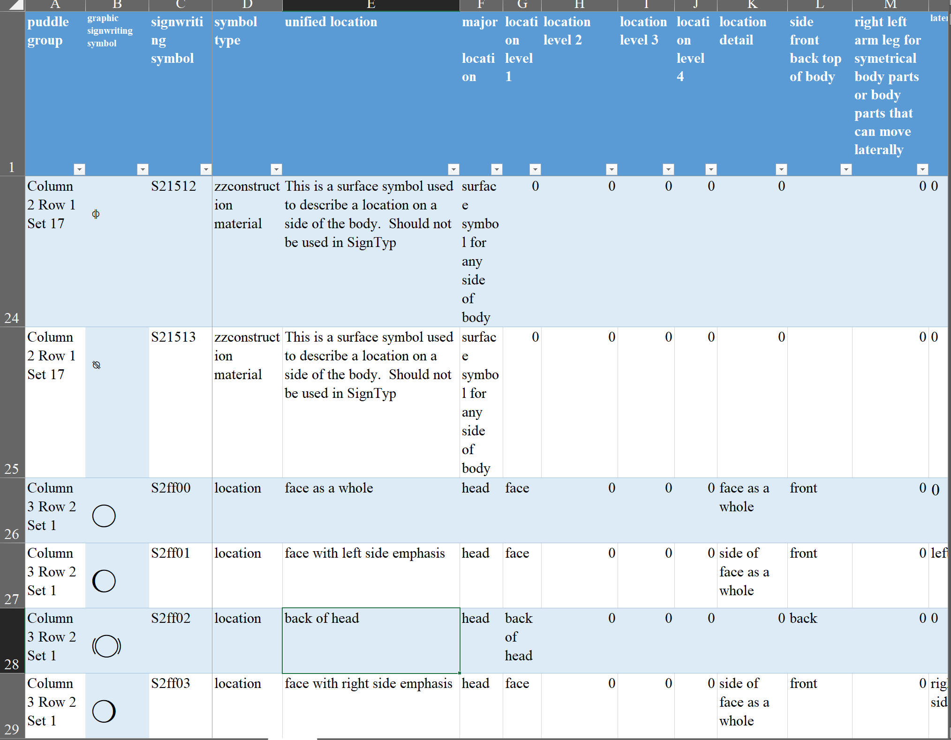
We are looking for chin. There are several ways to search this tab for chin. The simplest may be to use the excel find function (Ctrl + F) on column E – unified location. Select the “find all” option and it will tell you that there are 7 locations with chin:
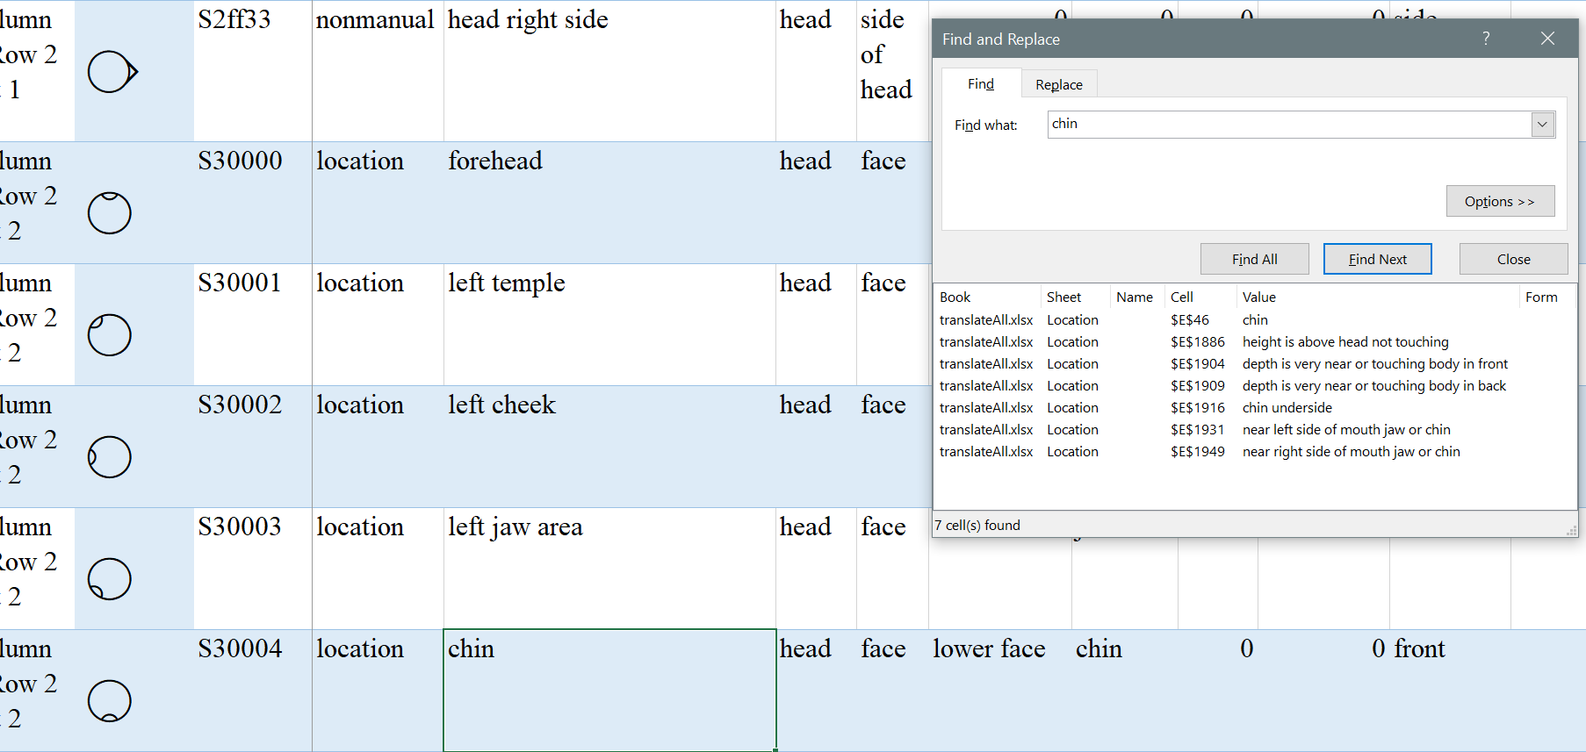
By looking at the value column in the find window, we can see that the first choice, on row 46 is probably the best. (For a sign like ASL PIG, the 5th choice, on row 1916 chin underside would be correct.) Notice that the find function can return unrelated values, such as the 2^{nd,} 3rd, and 4th choice which popped up because “touching” happens to include the letters c-h-i-n.
If we are looking for more complicated selections or we are not sure of the exact word to search for, it is better to look at the location fields in columns F through K. We will go through this method for chin.
Select the major location, head. There are 2094 location symbols. Selecting a major location of head narrows it down to 649 symbols. To do this, find the little down arrow at the top of column F and click on it to open it:
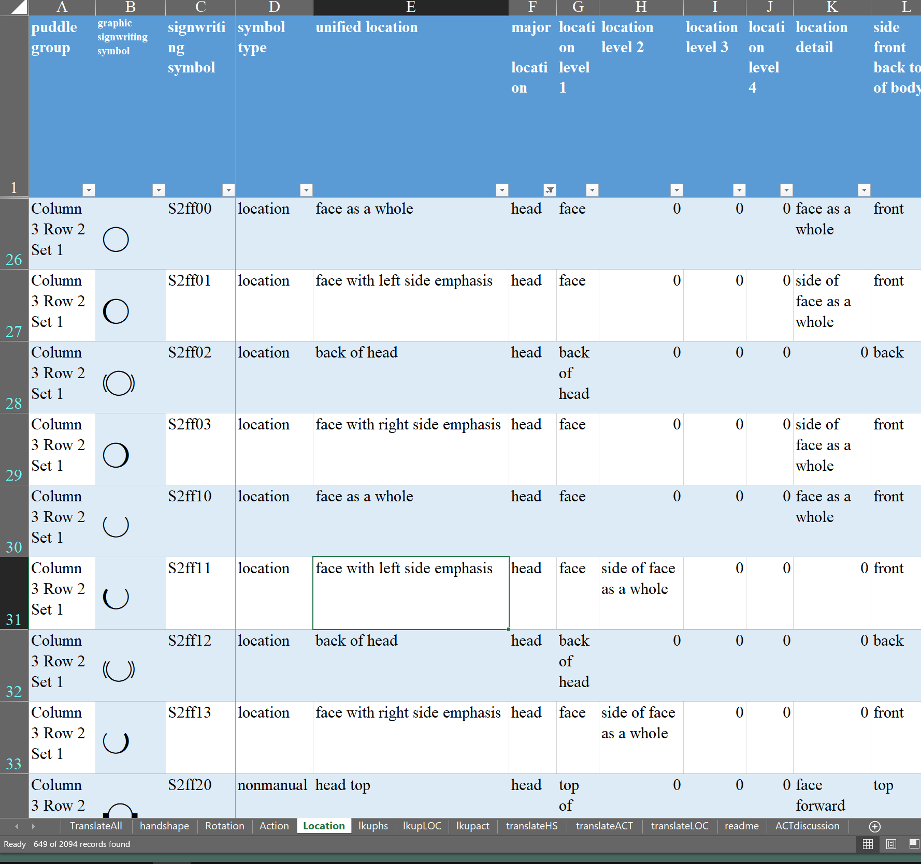
While we could select from the next location level in column G, we can also skip to location level 3 in column I and look there for chin: This reduces our choices to 2 and the correct choice here is the first one:
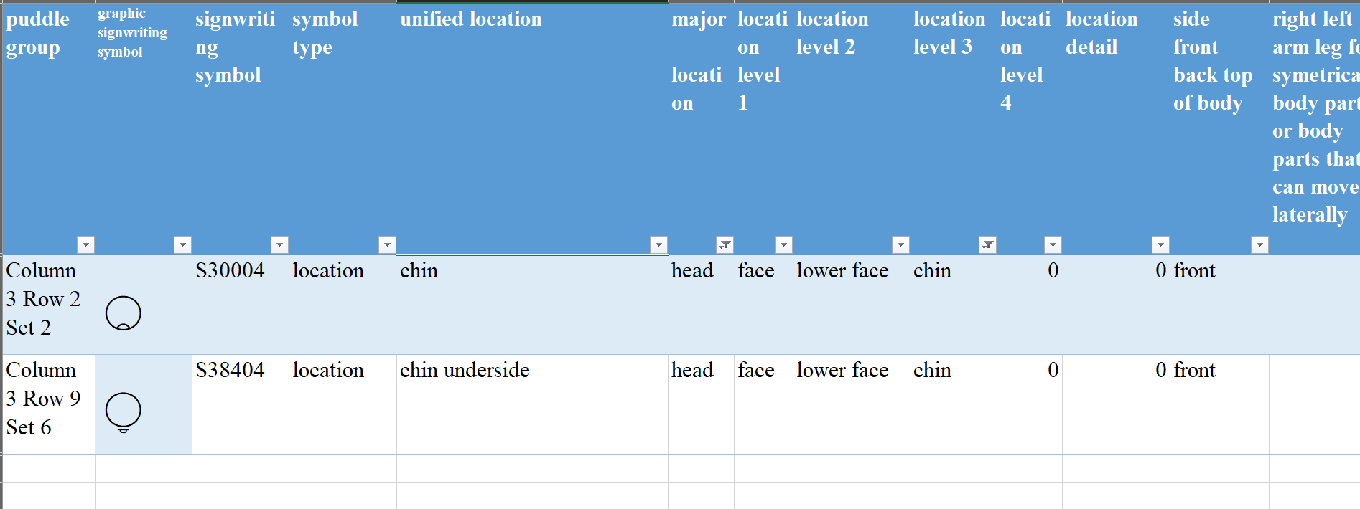
Column A shows us where to find this symbol – in the third column of the sign puddle, 2nd row, 2nd set
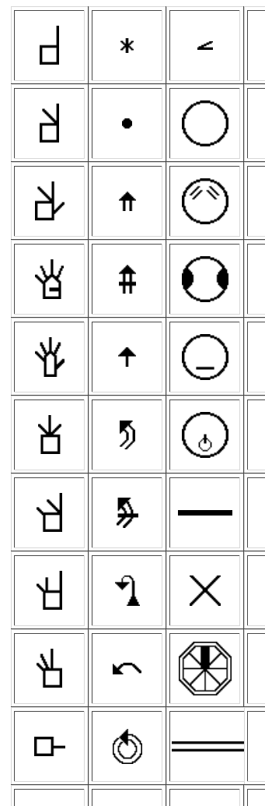
Clicking on column 3 row 2 gives us the sub-menu:
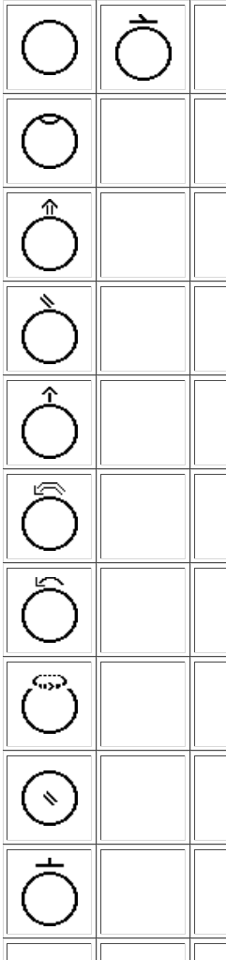
The second set is what we want so we click on that to get a sub-sub menu:
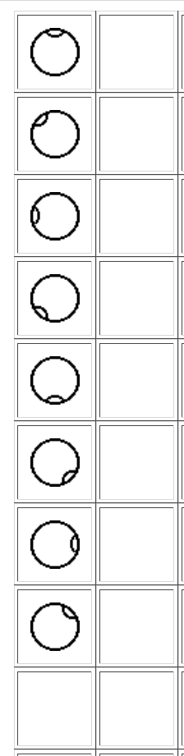
The chin is the 5th choice on this sub-sub menu.

Handshape
Open handshape tab:
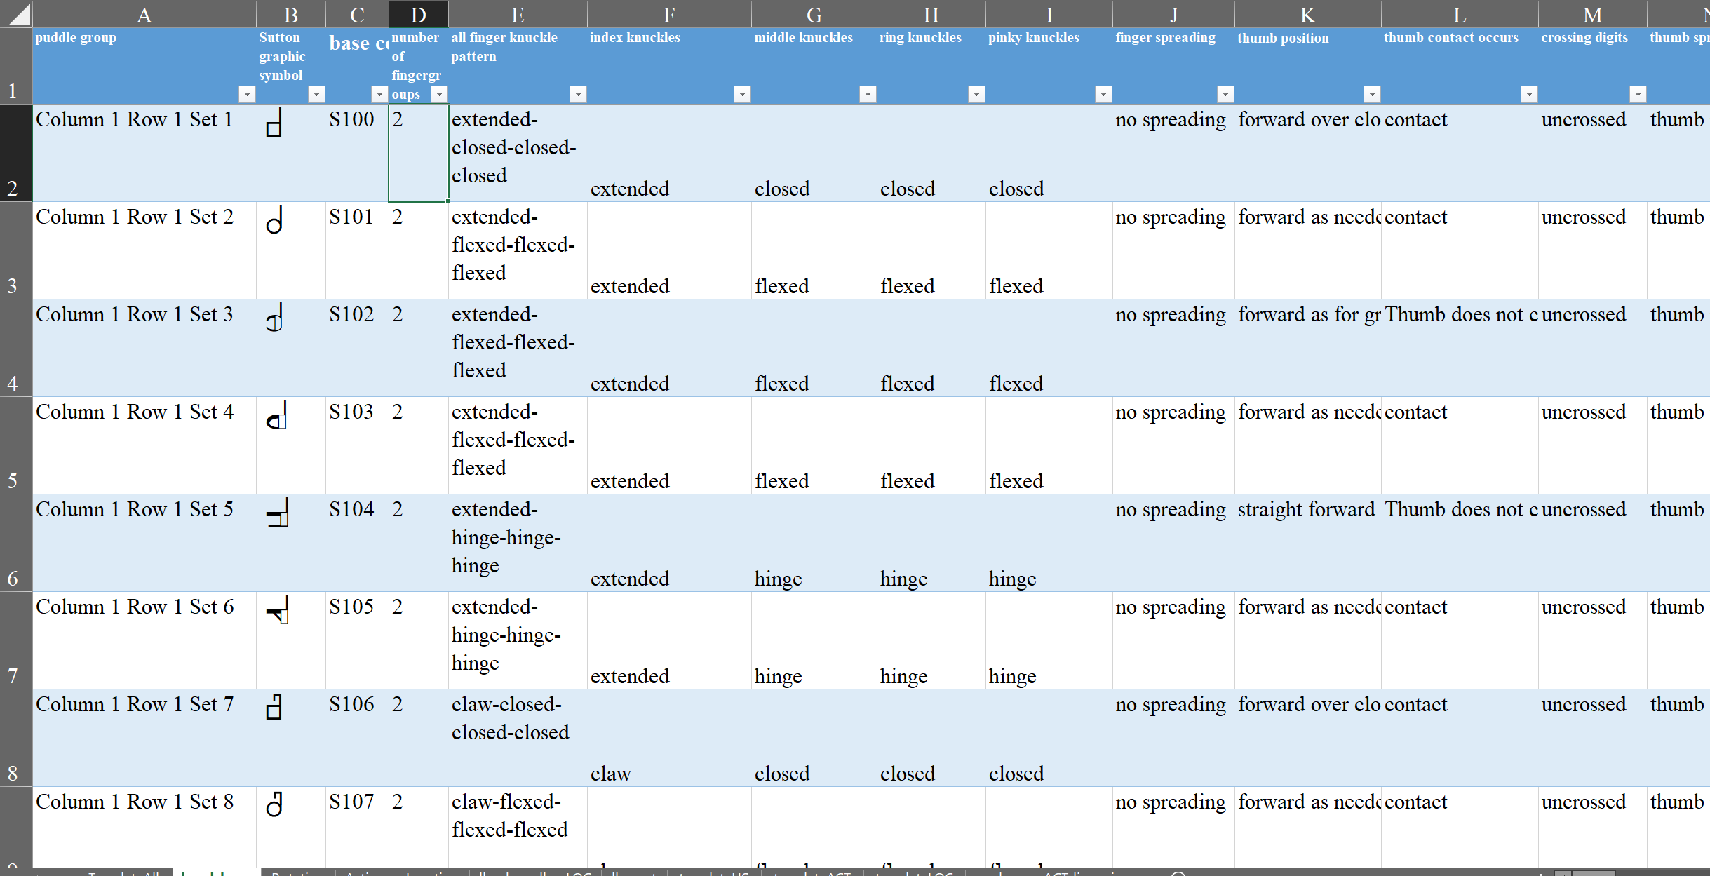
The handshape we need has one finger group, all fingers extended, no fingers spread, the thumb in the same plane as the palm, and no thumb contact. By selecting any of these characteristics, you can narrow down the choices, but usually, you will find that selecting the number of finger groups is a good first step. A finger group is a set of fingers that have the same knuckle bending. For example, the spread 5 hand has 1 finger group, while the pointing index has 2 finger groups (the extended index and the closed MRP).
Find the little down arrow at the top of the column, click on it to open it:
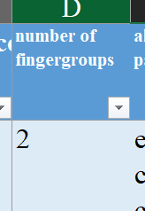

Select 1 fingergroup, and de-select all other choices.
Your screen will now change to show only those handshapes with 1 fingergroup:
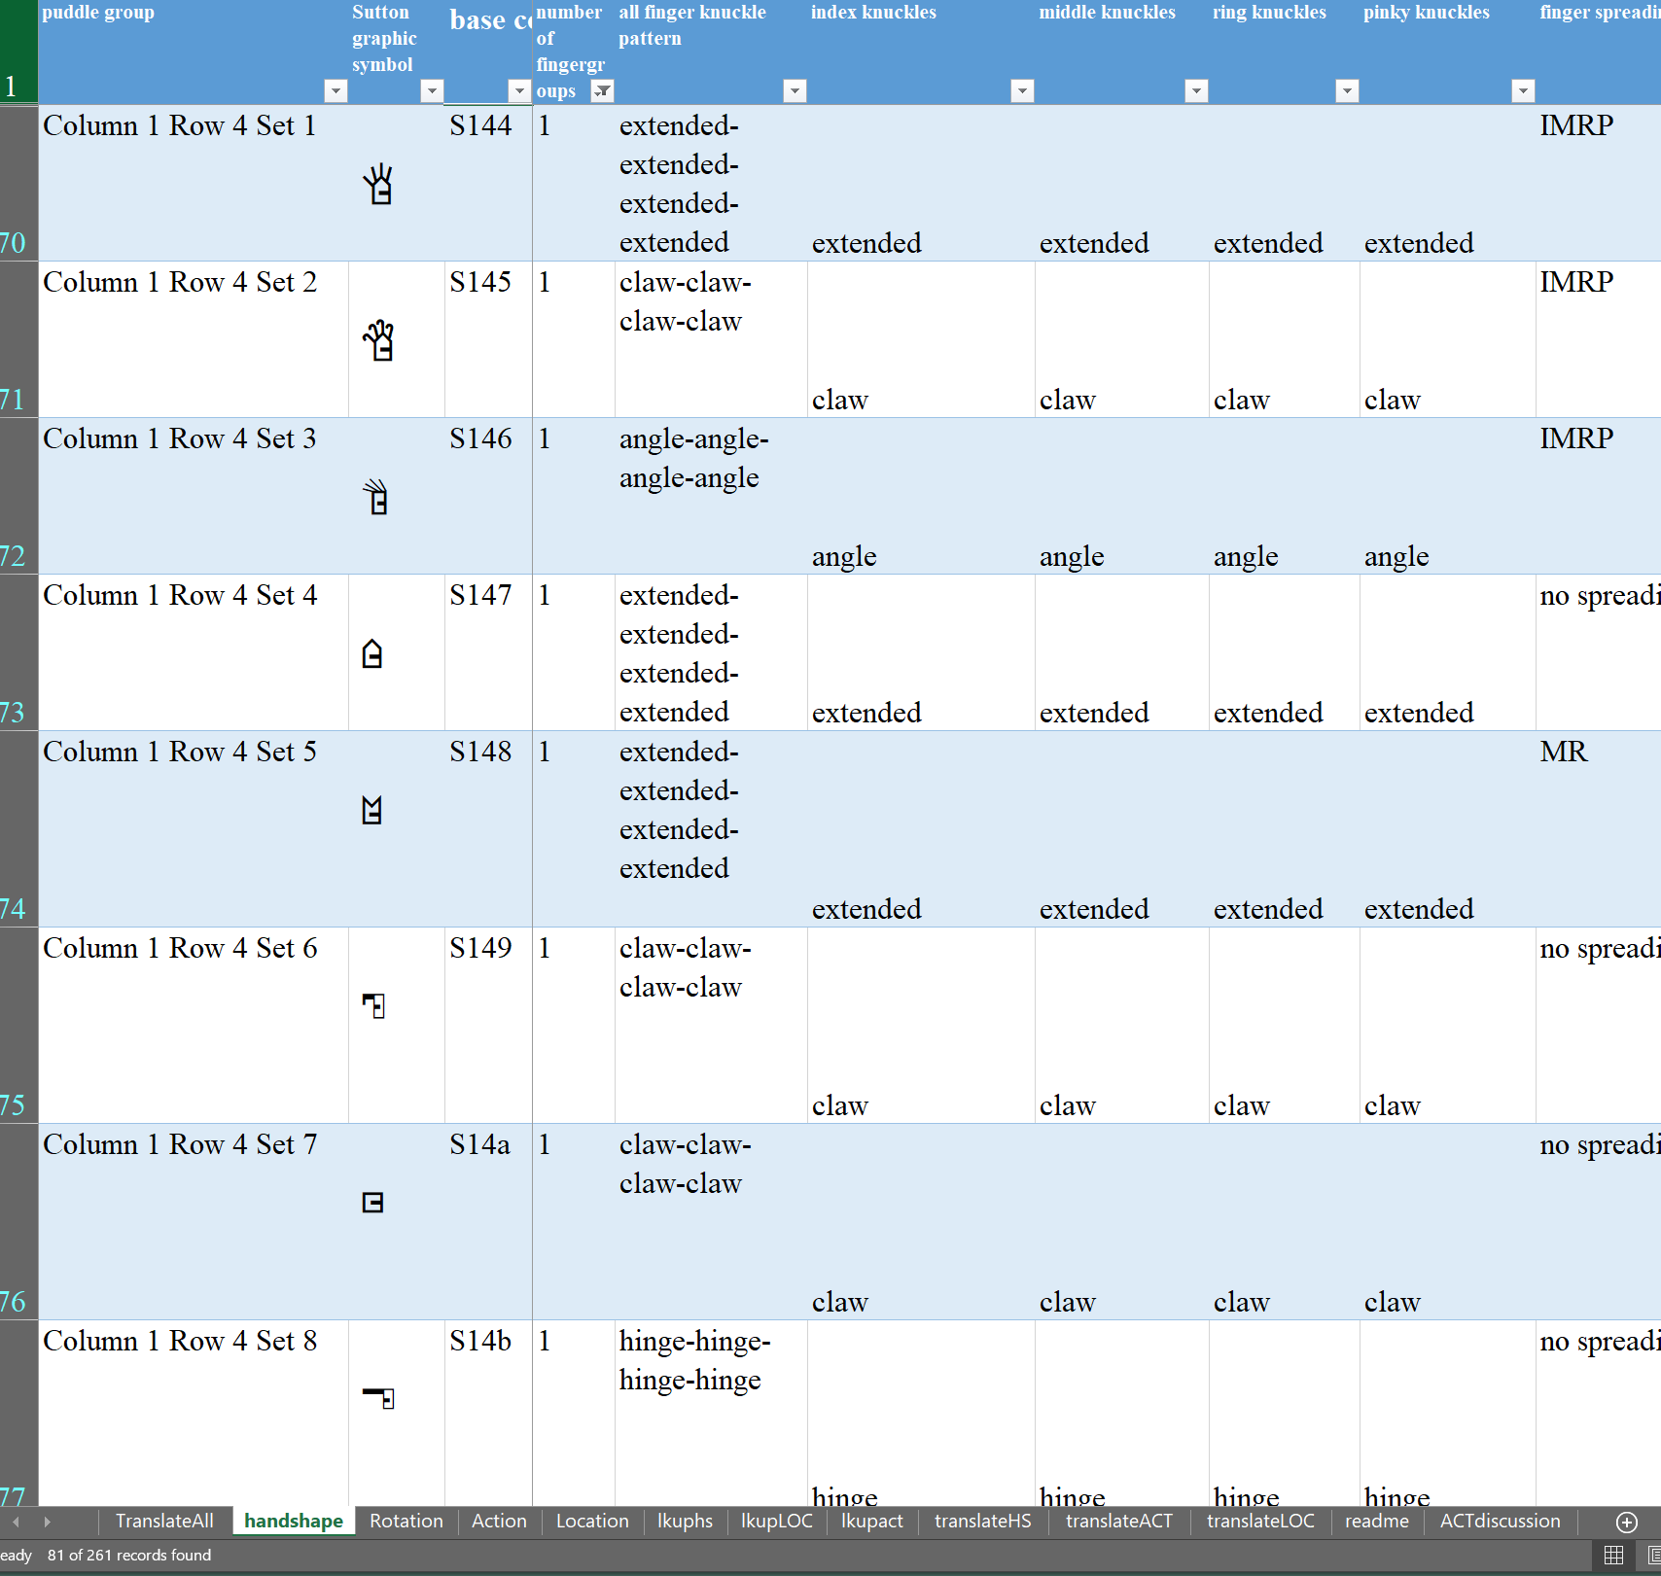
This reduces the number of handshapes from 261 to 81

To narrow down the choices to less than 5, we need to select a few more characteristics.
We can choose fingerspreading in column J, and select “no spreading”, which would bring our choices down to 57. Or we could select “extended” from any of the knuckle columns (E-G) because if all fingers are the same, any of them will produce the same set of choices and reduce the choices to 20:
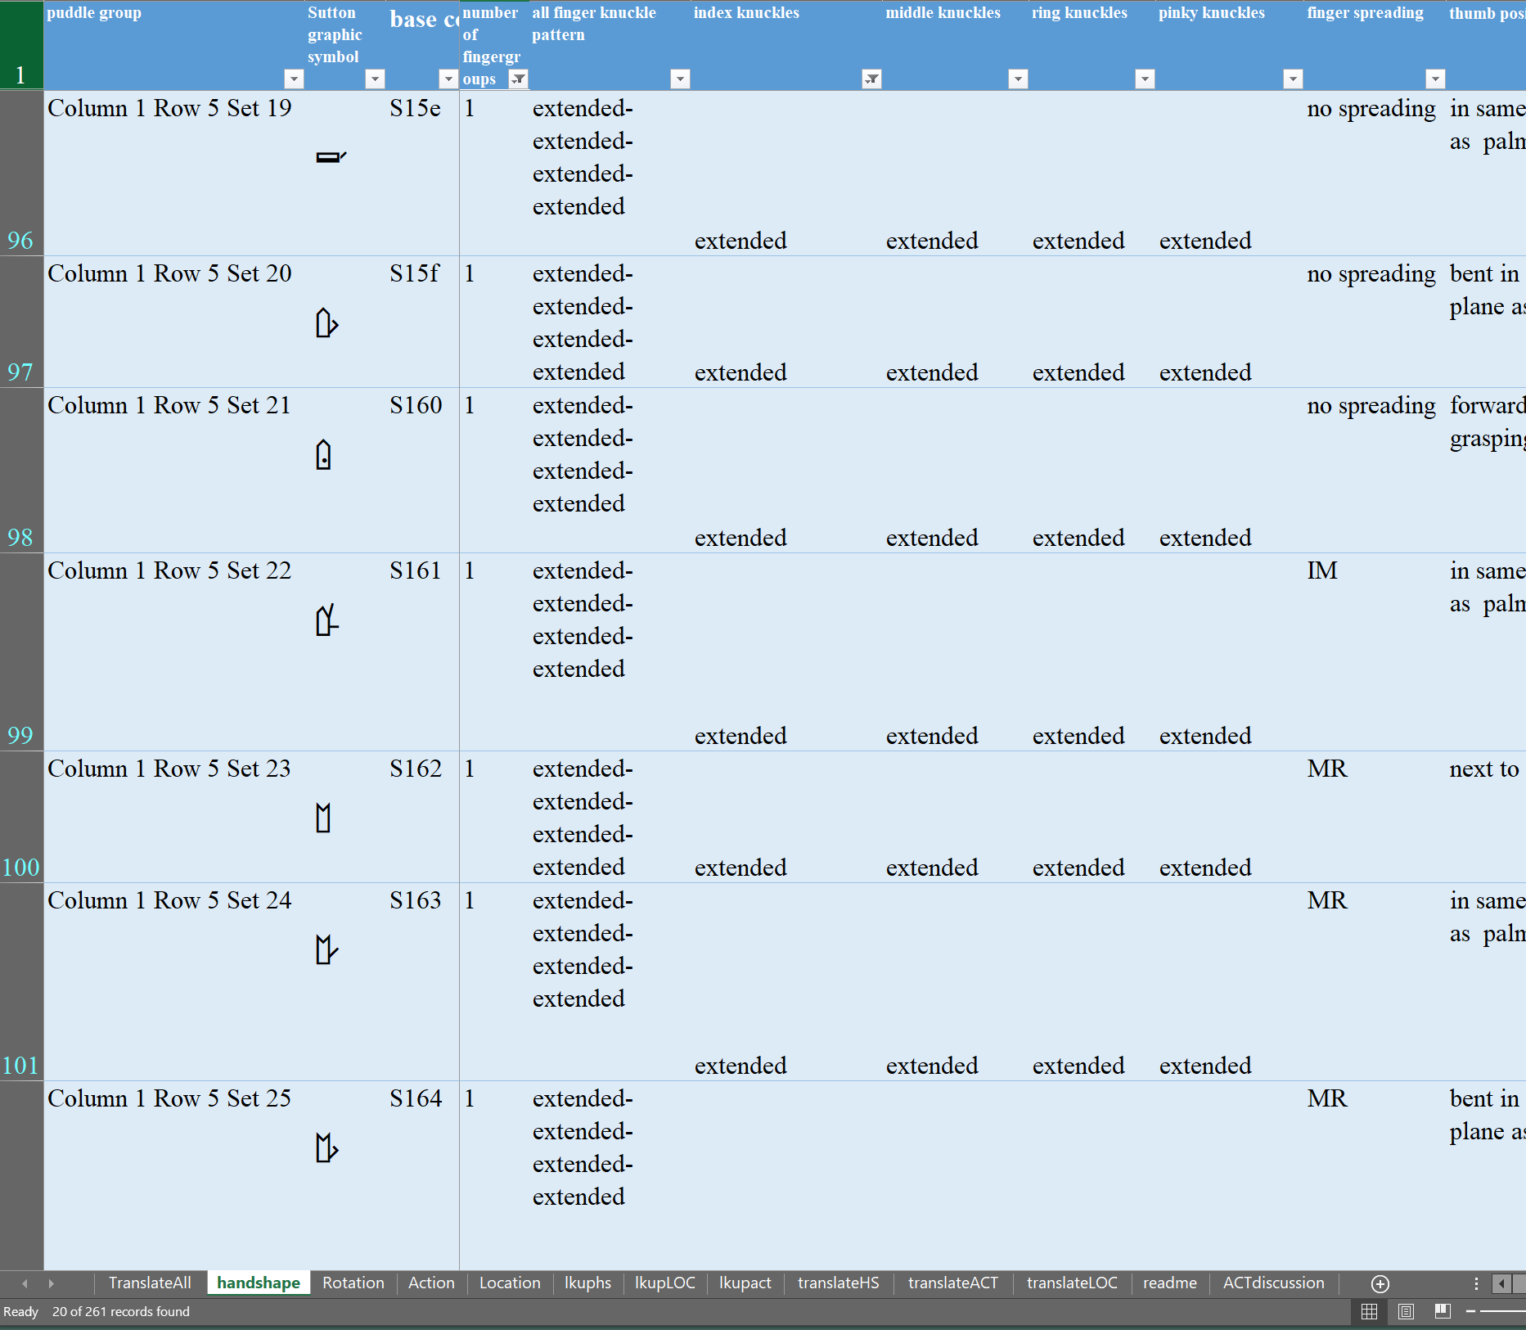
To reduce the set of choices further, we could specify thumb characteristics or spreading. Spreading is usually a better choice at this point, but it is not too important. We will choose finger spreading = no spreading and reduce our choices to 9:
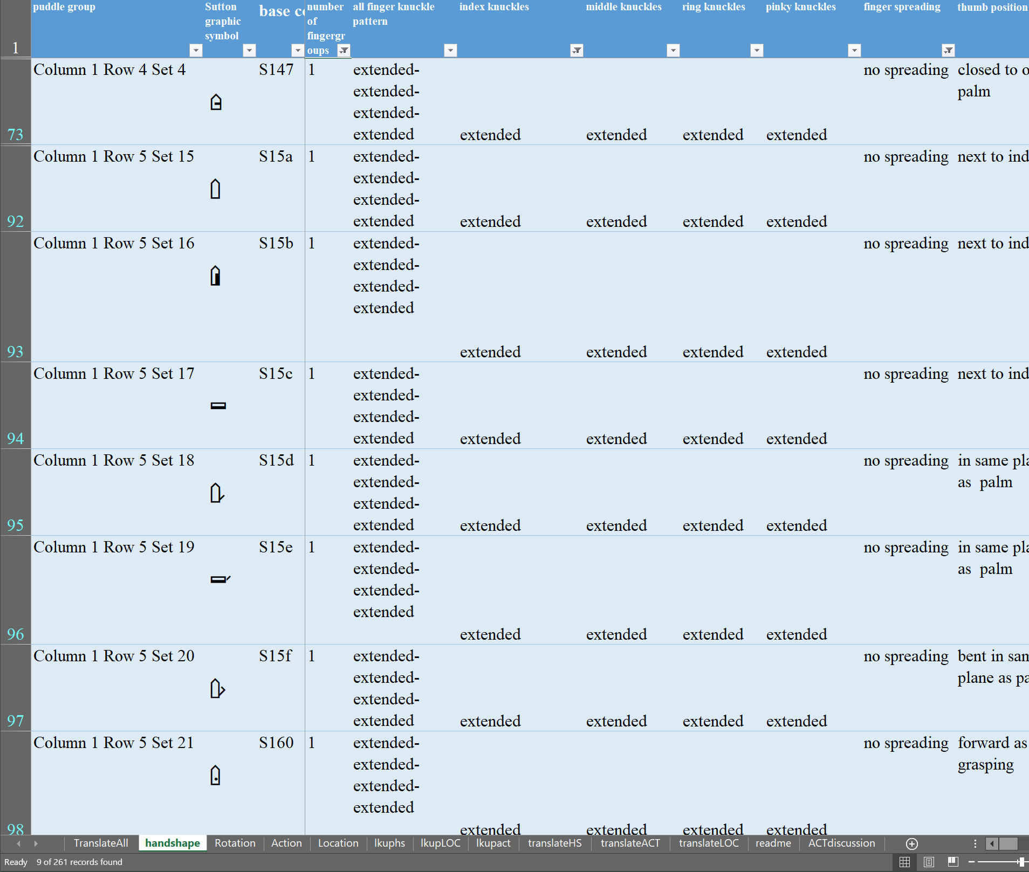
Our final selection is thumb position = next to index. We now have only three handshape symbols possible (which in this case are actually the same handshape from different perspectives):
:
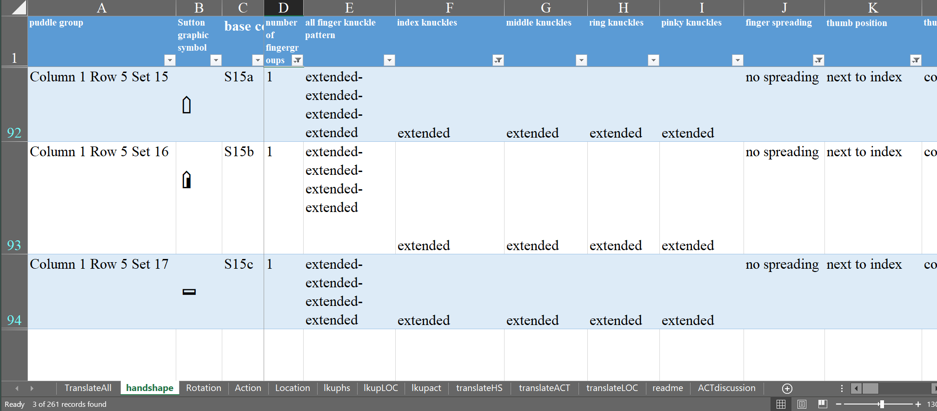
We now select symbol S15a, which we can locate in the sign puddle in column 1, row 5, the 15th set (as seen in column A).
Row 5:
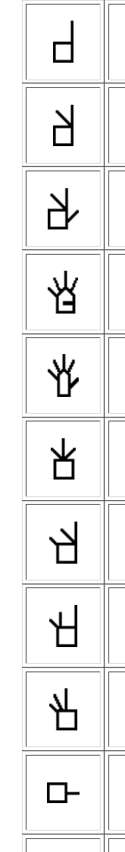

The red arrow shows Set 15:
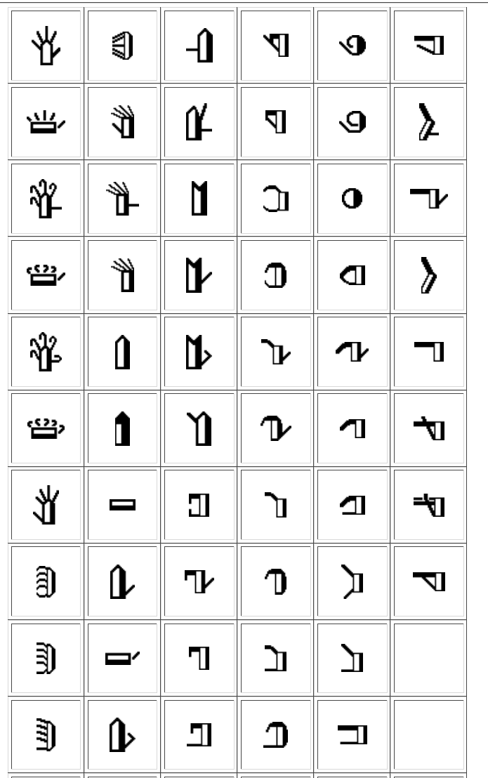
Once the handshape is selected, we need to determine the rotation (orientation).

Rotation
Rotation has two parts. Part 1 determines the facing of the palm or the thumbside of the hand. The palm can face toward the writer, toward the viewer, up or down. Palm symbols are either white or black. When the writer can see the palm (facing writer or up), it is white, otherwise (facing viewer or down) the symbol is black. Thumbside symbols can face up/down, or writer/viewer. The thumbside symbols are both black and white.
In some ways, thumbside symbols might be more correctly called side symbols because the same symbol is used regardless of which side faces up and regardless of which side faces the writer. For a specific posture, either the pinkyside or thumbside is more likely. For example, if the forearm is vertical at face level and the index finger pointing up, the thumbside will almost always face the writer, because to have the pinkyside face the writer means a very painful twisting of the arm. But if the arm hangs at the side in the posture one would use for holding a heavy suitcase, then usually the pinkyside will face the signer/writer, because for the thumbside to face the signer/writer, the arm must be twisted. However, in this position, it is possible to twist the arm, so both facings are possible, although one is more likely.
The left and right cardinal directions, where the frontal and floor plane intersect, will have duplicate symbols from each plane. For example, when the right hand is extended horizontally along the waistline with the palm facing down and the index pointing left, either a black symbol (showing the palm facing down) or a black and white symbol (showing the thumbside facing writer or viewer) can be used. Because of the indeterminacy of the thumbside black and white symbols as discussed in the previous paragraph , it is better to use palm orientation instead of thumbside orientation if both alternatives are possible.
Not every orientation is possible in Sutton SignWriting. An example of an orientation that is not possible is the diagonal facing with the palm facing down and toward the viewer and the extended index pointing up and toward viewer. The diagonal points on the sidewall circle are not available, nor are three direction points such as the index pointing viewer-up-left. When these orientations occur, approximations must be used, and comments can be used to mark these problems.
The second part of the rotation symbol is where the extended finger points. Obviously, many handshapes don’t have any fully extended finger. But regardless of whether any finger is actually extended, imagine that the index is fully extended and determine the direction it points in.
To select the correct rotation, go to the Rotation tab, and select the palm/thumbside facing in column B and select the (imaginary) pointing direction of the index finger in column C.
For the example sign THANKYOU, there are many possible orientations of the hand, as it moves down and out to its final position. Usually, we select the initial or contact point of the hand. In THANKYOU, the palm is facing the writer and the index points up when the hand contacts the chin. On the Rotation tab go to column K and insert the symbol code for the flat hand: S15a. (This step is not necessary but makes it easier to see when you have the right orientation of your symbol).
The Rotation tab will look like this: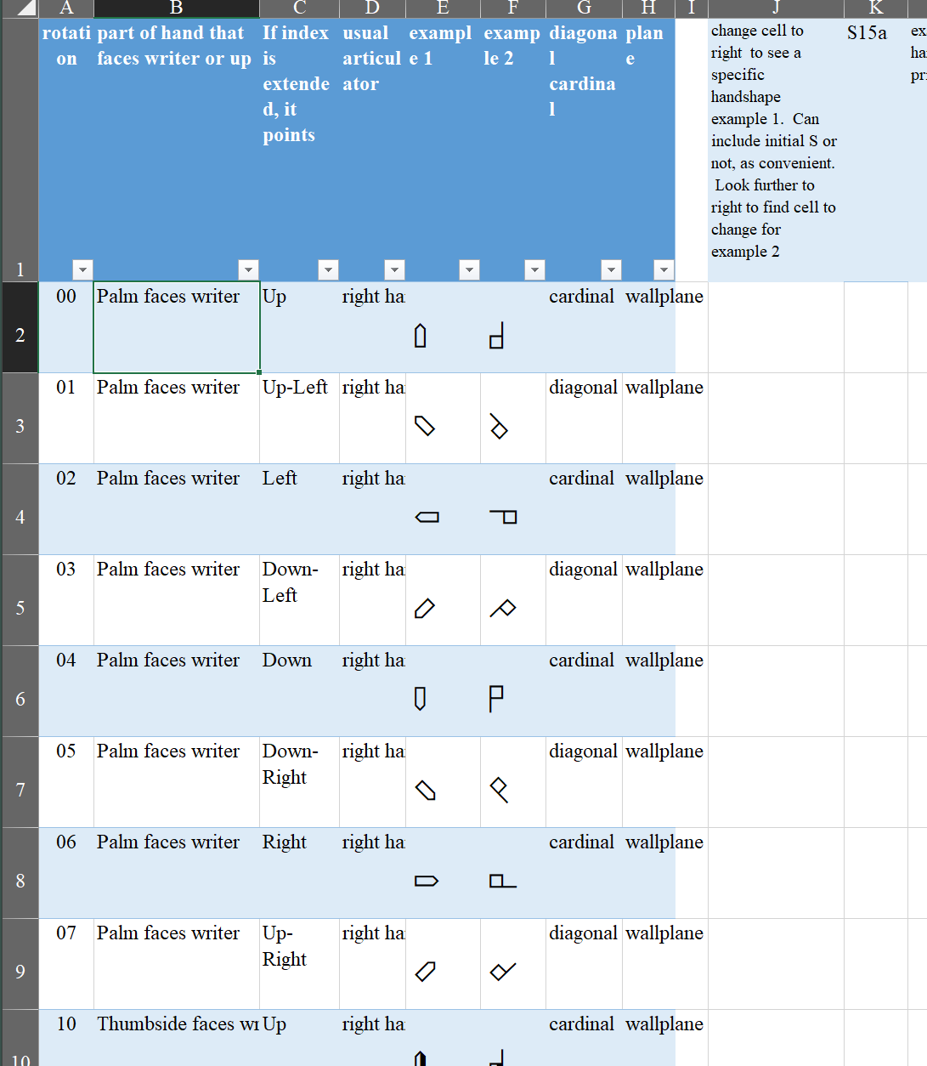

Now select the palm facing the writer and the index pointing up in columns B and C. The tab will now look like this:
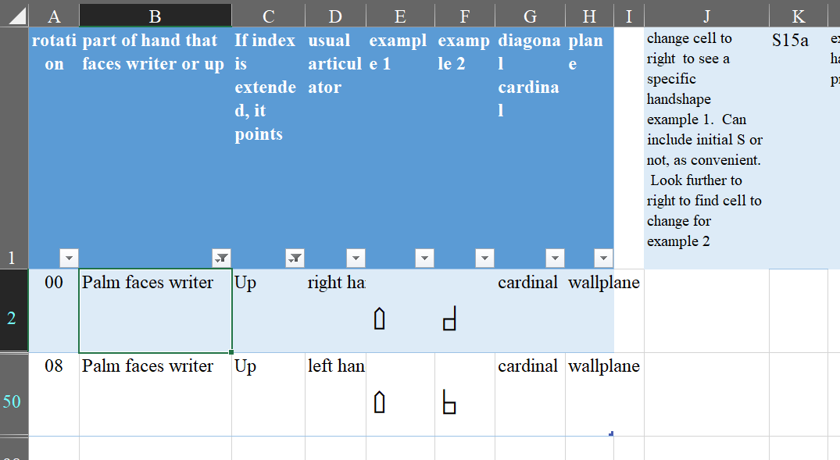
Note that both the right hand choice (rotation 00) and the left hand choice (rotation 08) are identical symbols. For Signwriting, either one could be used, but for SignTyp, it is very important to use the symbol that matches the correct rotation.
Note that in the sign puddle, the 96 rotations are in 6 columns and 16 rows that each start with 0. The six columns of possible palm facings are labelled 0,1,2,3,4,5. The 16 columns of possible index pointings are labelled 0 to f. The top 8 are the right hand pointings which are labelled 0,1,2,3,4,5,6,7. The bottom 8 are for the left hand, and are labelled 8,9,a,b,c,d,e,f.
Note that for SignTyp, rotations for the right hand are ALWAYS in the top 8 rows, and rotations for the left hand are ALWAYS in the bottom 8 rows. (This is not true for regular signwriting)
So, putting the handshape S15a with the correct rotation of 00, we go to the SignPuddle and navigate the menus:
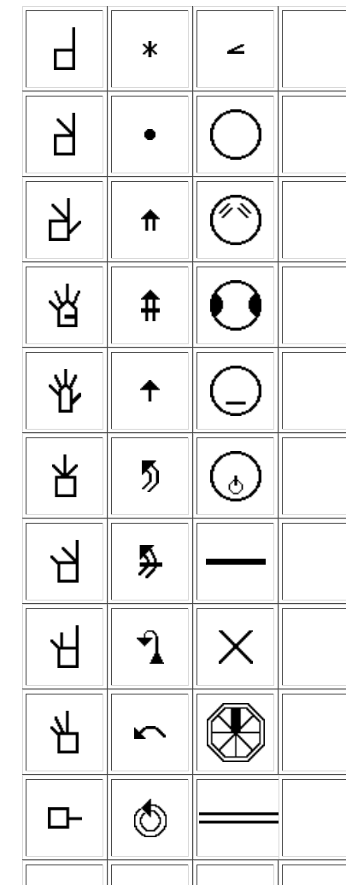

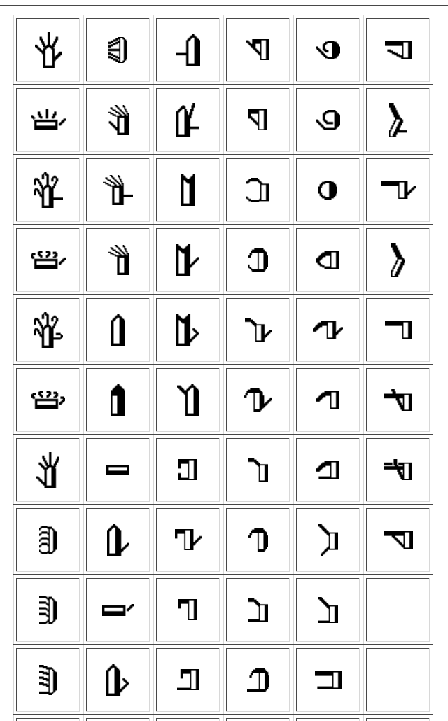

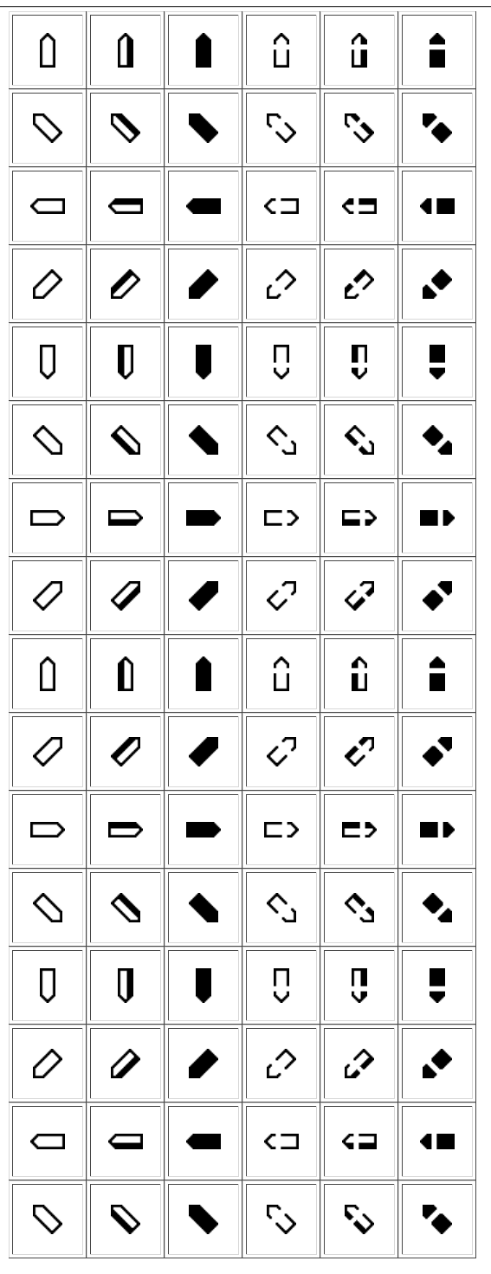

ACTION
In SignTyp it works best to select first the location, then the handshape, then the action for a gesture. Then your SignSpelling will be mostly correct and you will only need to make a few or even no corrections on the structured spelling screens.
The action of THANKYOU is a diagonal downward straight(ish) movement.
The Action tab has 11,134 symbols and part of it looks like this:
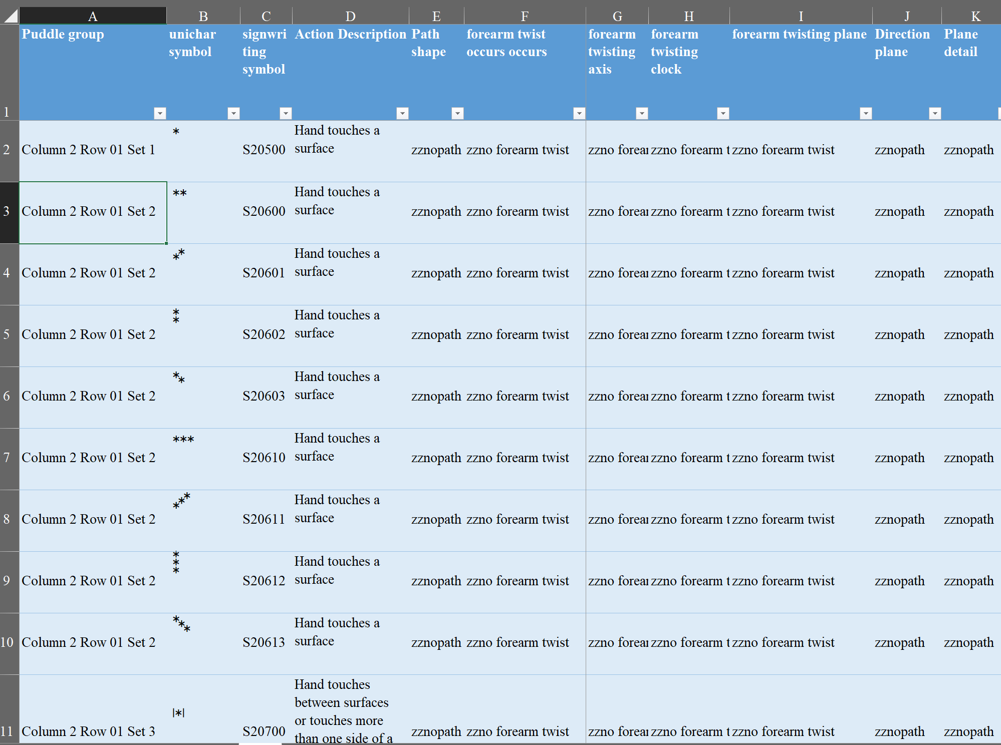
There are many features that you can select on but for this example, we will start with choosing path shape = Straight in column E and no forearm twist in column F. This reduces our choices to 864:
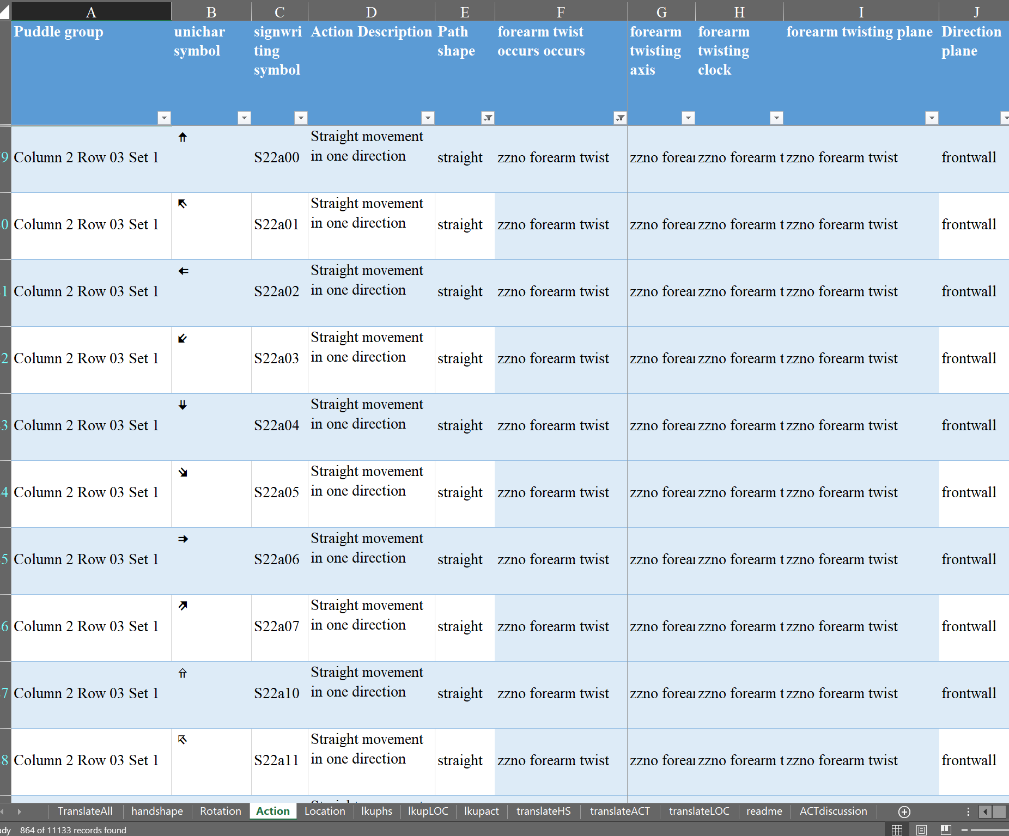

Next go to column M and select the first direction which is viewer-down, which brings us to 24 choices:
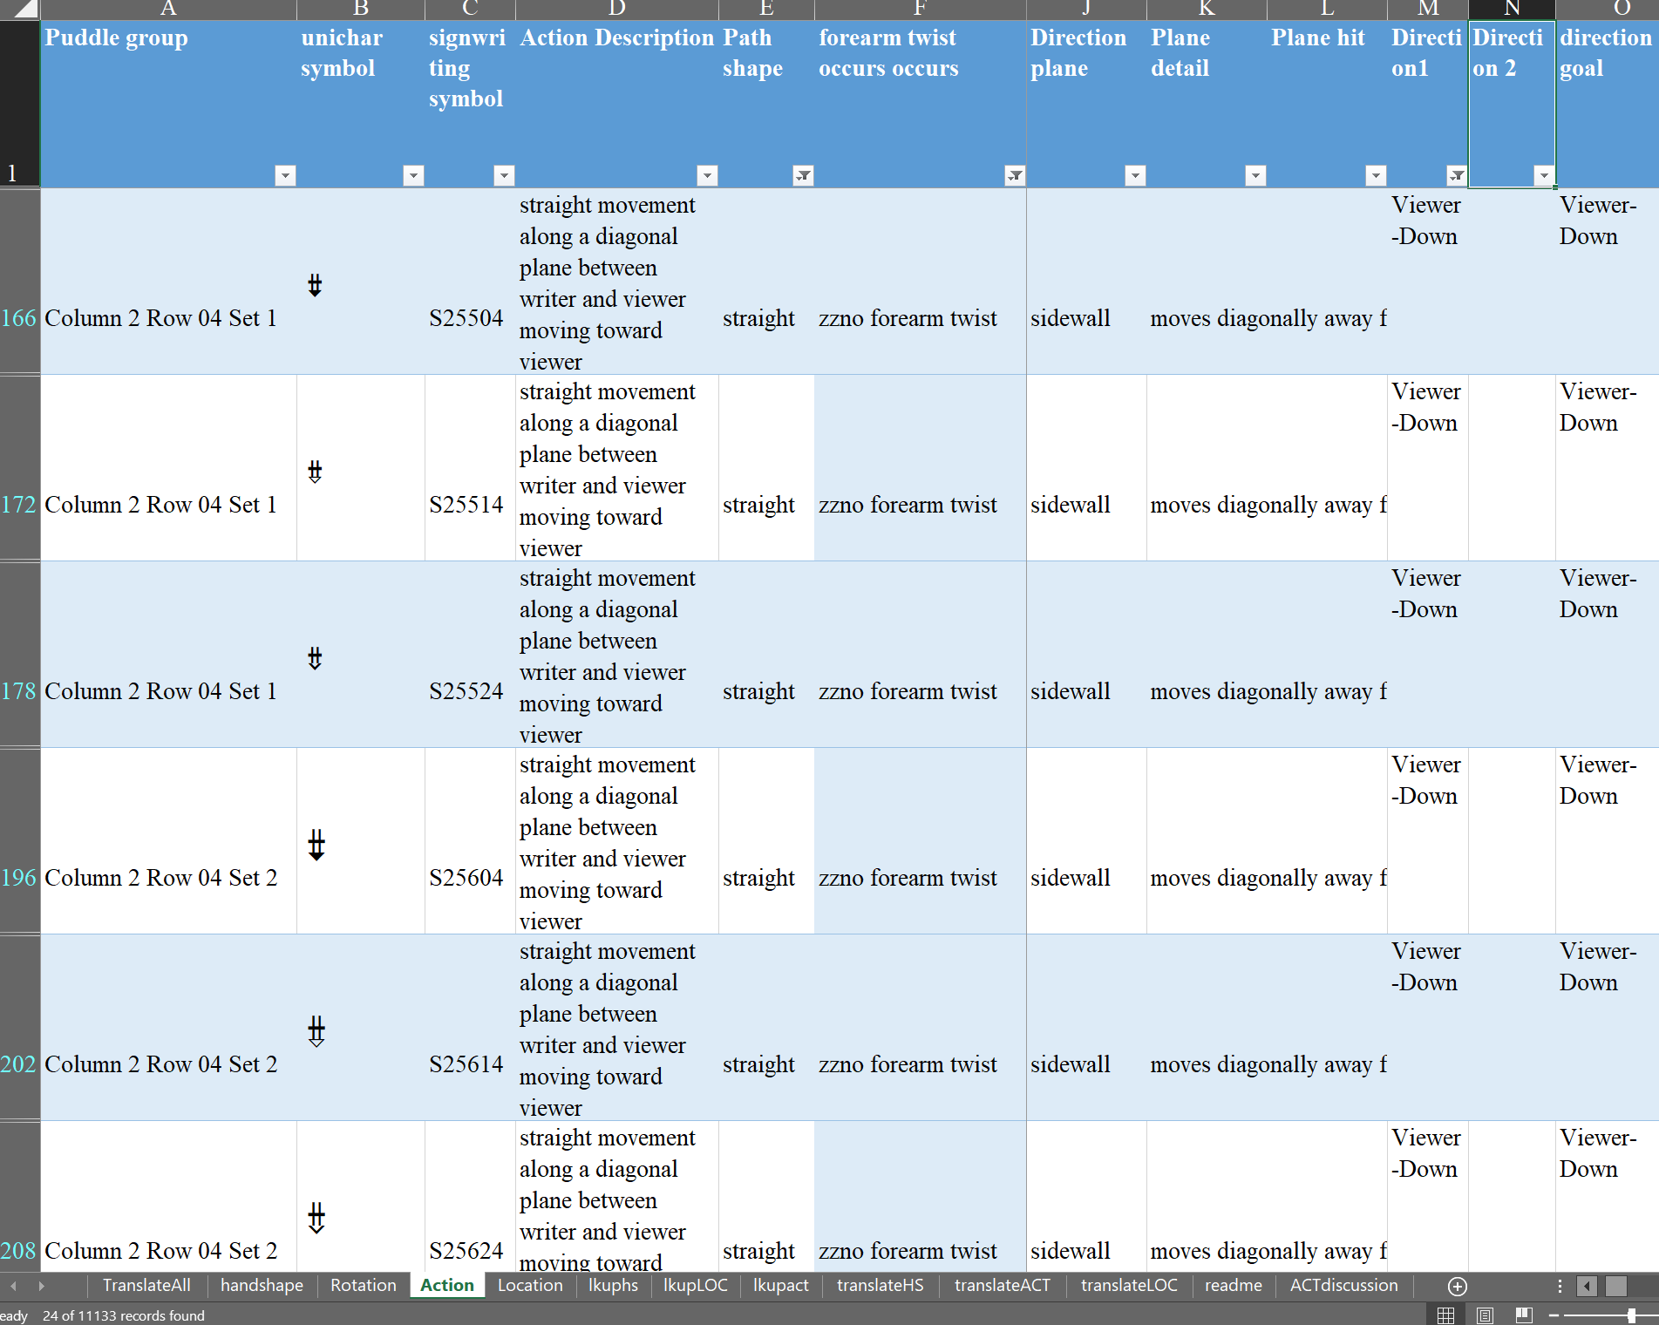
If we use column AB to select size moderate and column AL to select right hand used, we have two choices, which are (apparently) equivalent. 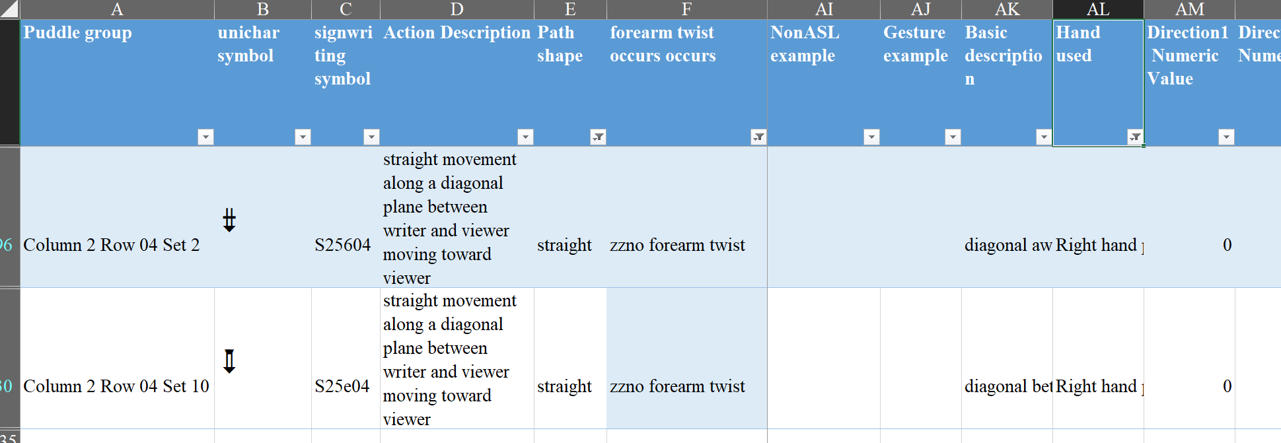

The first choice is in column 2 row 4 set 2, so we go back to the sign puddle and hunt through the sub menus:

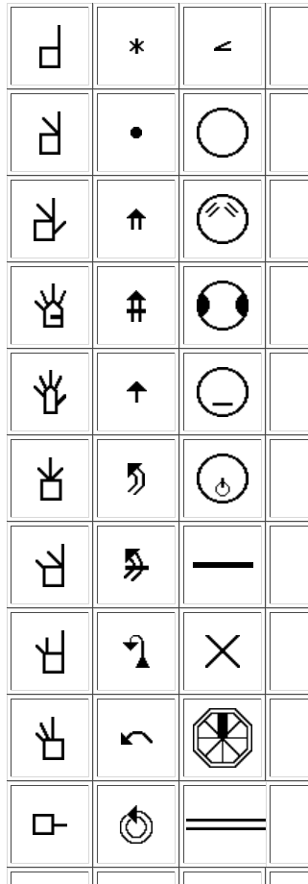
Column 2 row 4 gives us this submenu:
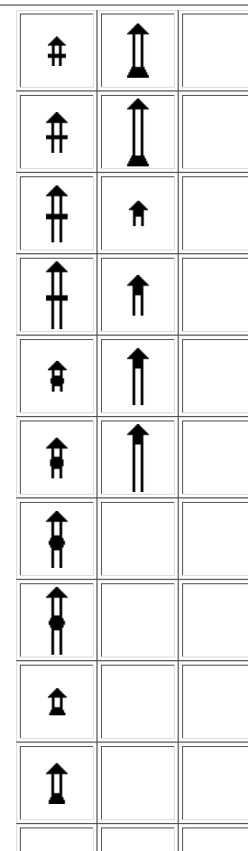
And set 2 provides this menu:
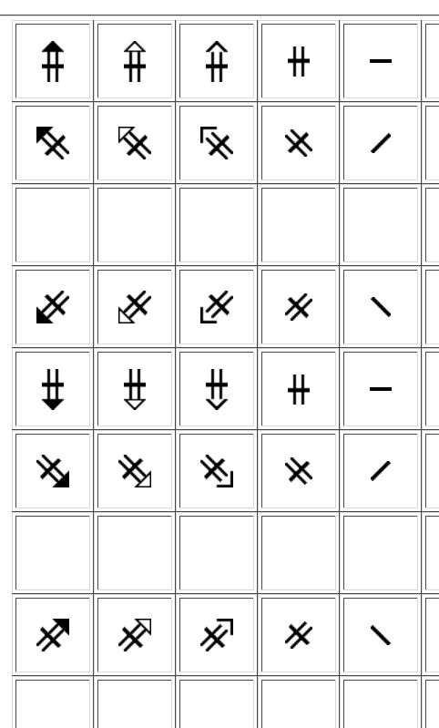
The symbol in the first column fifth row matches our choice so that is what we use.

ALL TOGETHER NOW
The complete writing of THANKYOU will look like this. Notice that there is also a touch symbol (the star) which should be added for SignTyp whenever there is body contact (for normal signwriting this is often omitted):
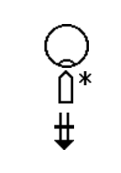

Although this is a relatively simple example, the TranslateAll spreadsheet can be very helpful when you are learning signwriting, or when you are looking for less common handshapes, actions or locations whose placement is not always obvious. It is also a way to make sure that you have the correct rotation for your handshape, and the correct direction for your actions. It is easy to confuse actions that move between writer and viewer for actions that move up and down.

Rachel Channon
October 22, 2018

